BERT-Based Automatic Question Classification Using Deep Learning
A Mini Project Report Submitted in partial fulfillment of the requirements for the award of the degree of

BACHELOR OF TECHNOLOGY
In
Department of Computer Science and Engineering (CSE)

By
M.Sai Sahasra — 2420030706
Ch.Lucky Reddy— 2420030739
R.Vignesh Reddy — 2420090006
K.Sai Krishna— 2420030632

Under the Esteemed Guidance of
Dr. K. Swanthana

K L (Deemed to be) University

K L (Deemed to be) University
Department of Computer Science and Engineering (CSE)

DECLARATION

The mini-project report entitled “BERT-Based Automatic Question Classification Using Deep Learning” is a record of bona fide work carried out by M.Sai Sahasra (2420030706), Ch.Lucky Reddy(2420030739), R.Vignesh Reddy (2420090006) and K.Sai Krishna(2420030632) in partial fulfillment of the requirements for the award of the B.Tech degree at K L (Deemed to be) University. The work presented in this report is original to the best of our knowledge, and all datasets, tools, code, and external sources used have been appropriately acknowledged.

K L (Deemed to be) University
Department of Computer Science and Engineering (CSE)

CERTIFICATE

This is to certify that the mini-project report entitled “BERT-Based Automatic Question Classification Using Deep Learning” is a bona fide work carried out by M.Sai Sahasra (2420030706), Ch.Lucky Reddy(2420030739), and R.Vignesh Reddy (2420090006) and K.Sai Krishna(2420030632) under the supervision of Dr. K. Swanthana during the academic year 2026–2027, in partial fulfillment of the requirements for the award of the Bachelor of Technology degree at K L (Deemed to be) University.

Signature of the Project Supervisor | Signature of the HOD | Signature of the External Examiner

ACKNOWLEDGEMENT
The success of this project would not have been possible without the timely help and guidance of the people who assisted us in its completion.
We express our sincere gratitude to our Applied Machine Learning for Text Analytics faculty guide, Dr. K. Swanthana, for the support, encouragement, and guidance provided throughout this project.
We express our gratitude to the Head of the Department and K L (Deemed to be) University for providing the facilities and academic environment required to complete this project-based laboratory work.
We thank the teaching and non-teaching staff members, and everyone who assisted us directly or indirectly. Finally, we sincerely thank our parents, friends, and classmates for their help and cooperation.

TABLE OF CONTENTS
S. No. | Contents | Page No.
1. | Abstract | 6
2. | Introduction | 7
3. | Literature Survey | 8
4. | Problem Statement and Objectives | 10
5. | Hardware and Software Requirements | 11
6. | Implementation | 12
7. | Results & Discussion | 16
8. | Conclusion & Future Scope | 18
9. | References | 20

1. ABSTRACT
Nowadays, students, teachers, and online learning platforms deal with a large number of questions across various academic subjects. Organizing these questions manually into appropriate categories is a time-consuming process and may lead to errors. This project proposes an Intelligent Question Classification System Using BERT that applies Artificial Intelligence (AI) and Natural Language Processing (NLP) to automatically classify questions based on their meaning and context. The proposed system accepts questions as text input, preprocesses the text, and uses a pre-trained BERT (Bidirectional Encoder Representations from Transformers) model fine-tuned for question classification. Unlike traditional machine learning techniques that primarily depend on keywords, BERT considers the contextual relationships between words to identify the meaning of a complete question. The system classifies questions into predefined academic categories such as Science, Mathematics, History, Geography, Computer Science, and General Knowledge. After processing the input, the model generates the predicted category along with a confidence score indicating its estimated certainty. The model's performance is evaluated using standard classification metrics, including Accuracy, Precision, Recall, and F1-Score. The trained model is integrated into a web application developed, providing a simple interface where users can enter questions and obtain classification results. The system is intended to support educational websites, online examination platforms, digital libraries, FAQ management systems, and AI-powered chatbots. By automating the categorization process, the project aims to reduce manual effort, improve question organization, and make information retrieval more efficient. The practical objective of this project is to demonstrate how transformer-based language models can be applied to intelligent question classification and educational content management.
Team Name: Group 4

Team Members and Responsibilities
S. No. | Team Member | Roll Number | Responsibility
1 | M. Sai Sahasra | 2420030706 | Project team member; Collaborative contribution to all project activities, including design, implementation, testing, and documentation.
2 | Ch.Lucky Reddy | 24200300739 | Project team member; Collaborative contribution to all project activities, including design, implementation, testing, and documentation.
3 | R.Vignesh Reddy | 2420090006 | Project team member; Collaborative contribution to all project activities, including design, implementation, testing, and documentation.
4 | K.Sai Krishna | 2420030632 | Project team member; Collaborative contribution to all project activities, including design, implementation, testing, and documentation.

Dataset/source and project repository (if applicable):
- Python Documentation: https://docs.python.org/3/
- Java Documentation: https://docs.oracle.com/javase/
- TensorFlow Documentation: https://www.tensorflow.org/
- User-uploaded technical documents in PDF, DOCX, and TXT formats.

Project repository URL: https://github.com/Sahasra2420030706/KLH-CSE-2026-27-2420030706-BERT-Based-Automatic-Question-Classification-

2. INTRODUCTION

In the modern educational environment, students, teachers, and online learning platforms handle large numbers of questions across different subjects. Manually organizing these questions into appropriate categories is time-consuming and may lead to errors. Therefore, an automated system is needed to classify questions efficiently and accurately.

This project focuses on developing a BERT-Based Automatic Question Classification System using Natural Language Processing (NLP). The system uses a fine-tuned BERT model to classify questions into categories such as Science, Mathematics, History, Geography, Computer Science, and General Knowledge based on their contextual meaning. It also provides a confidence score for each prediction.

The proposed workflow includes dataset preparation, text preprocessing, BERT model training, performance evaluation, and integration with a python web application. The model is evaluated using Accuracy, Precision, Recall, and F1-Score. This system aims to reduce manual effort and improve question organization in educational platforms and intelligent learning applications.

Project Workflow

Stage | Description
1. Dataset Collection and Preparation | Collect a labeled dataset containing questions from different categories, such as Science, Mathematics, History, Geography, Computer Science, and General Knowledge.
2. Text Preprocessing | Clean the question text by removing unnecessary spaces, handling missing values, and preparing the dataset for model training.
3. Text Tokenization | Use the BERT tokenizer to convert questions into token IDs and attention masks required by the model.
4. Dataset Splitting | Divide the labeled dataset into training, validation, and testing sets to train the model and evaluate its performance.
5. BERT Model Fine-Tuning | Fine-tune a pre-trained BERT model using labeled questions so that it learns to classify questions into the predefined categories.
6. Question Classification and Prediction | Process a user's input question using the trained model and predict its most appropriate category along with a confidence score.
7. Model Evaluation and Testing | Evaluate the model using Accuracy, Precision, Recall, and F1-Score to assess its classification performance.
8. Web Application and User Interaction | Integrate the trained BERT model into a web application where users can enter questions and instantly view the predicted category and confidence score.

3. LITERATURE SURVEY
The supplied reference document identifies ten papers relevant to neural question generation, Transformer models, benchmark datasets, and automatic evaluation. The summaries below focus on each source’s relevance to this project. Where the supplied reference list does not provide detailed experimental settings or numerical findings, the report avoids inventing them.

1. BERT: Pre-training of Deep Bidirectional Transformers for Language Understanding

Devlin et al. (2019) introduced BERT, a transformer-based model that understands words based on their surrounding context. The study demonstrated that pre-trained language models can be fine-tuned for text classification tasks. This research forms the foundation of the proposed question classification system. BERT helps classify questions by understanding their contextual meaning.

2. Learning Question Classifiers

Li and Roth (2002) explored supervised learning techniques for classifying questions into semantic categories. Their research introduced a question-classification dataset and methods for identifying question types. This study highlights the importance of labeled datasets in training classification models. The proposed project extends this approach using contextual representations from BERT.

3. Attention Is All You Need

Vaswani et al. (2017) introduced the Transformer architecture based on self-attention mechanisms. It enables models to identify relationships between words in a sentence efficiently. This architecture became the foundation for models such as BERT. The proposed system uses BERT's transformer architecture to understand questions and predict their categories.

4. Convolutional Neural Networks for Sentence Classification

Kim (2014) proposed a convolutional neural network approach for sentence classification using pre-trained word embeddings. The study demonstrated the effectiveness of neural networks in learning useful textual features. However, its approach differs from BERT's contextual language understanding. This project uses BERT to capture the context of words when classifying questions.

5. Bag of Tricks for Efficient Text Classification

Joulin et al. (2017) introduced fastText, an efficient method for text classification using word representations and character n-grams. The approach provides fast and computationally efficient classification. However, it relies more on word-level features than deep contextual representations. The proposed system uses BERT to understand the context and meaning of questions.

6. Efficient Estimation of Word Representations in Vector Space

Mikolov et al. (2013) introduced methods for learning word embeddings from large text collections. These representations capture relationships between words and improve various NLP tasks. The research contributed to the development of modern language-processing systems. The proposed project uses BERT to generate contextual word representations for question classification.

7. GloVe: Global Vectors for Word Representation

Pennington, Socher, and Manning (2014) introduced GloVe, a method for learning word representations using global word-co-occurrence statistics. These embeddings capture semantic relationships between words. However, traditional GloVe embeddings remain static regardless of sentence context. The proposed BERT-based system generates contextual representations to improve question understanding.

8. Universal Language Model Fine-tuning for Text Classification

Howard and Ruder (2018) introduced ULMFiT, a transfer-learning approach for adapting pre-trained language models to text-classification tasks. Their research demonstrated the benefits of transferring language knowledge to specific applications. This concept is relevant to fine-tuning BERT for question classification. The proposed system adapts a pre-trained model to predefined academic categories.

9. RoBERTa: A Robustly Optimized BERT Pretraining Approach

Liu et al. (2019) introduced RoBERTa, an optimized version of BERT that improves language-model pre-training strategies. Their study highlighted the importance of training procedures for contextual language understanding. RoBERTa provides an alternative approach for downstream NLP tasks. The proposed project focuses on fine-tuning BERT for classifying questions into academic subjects.

10. Question Classification Using Support Vector Machines

Zhang and Lee (2003) investigated the use of Support Vector Machines (SVMs) for question classification. Their approach used linguistic and lexical features to assign questions to predefined categories. This research provides a foundation for traditional question-classification techniques. The proposed project uses BERT to capture contextual information beyond manually designed features.

Research Gap
The surveyed studies mainly focus on question classification, text representation, Transformer models, and NLP techniques as separate research problems. However, there is a need for an integrated system that can automatically classify questions into different academic categories using contextual understanding. Traditional methods may rely on keywords and struggle to identify the meaning of questions expressed in different ways. The proposed project addresses this gap by fine-tuning BERT for automatic question classification and integrating it with a Streamlit web application. The system aims to simplify question categorization and improve accessibility, while its effectiveness will be assessed using standard classification metrics without assuming unverified performance improvements.

4. PROBLEM STATEMENT AND OBJECTIVES

Problem Statement:

To develop a BERT-based system that automatically classifies questions into appropriate academic categories by understanding their contextual meaning.

Problem Description:

Students, teachers, and educational platforms handle large numbers of questions across different subjects. Manually categorizing these questions is time-consuming and may lead to errors. The proposed system uses a fine-tuned BERT model to classify questions into categories such as Science, Mathematics, History, Geography, Computer Science, and General Knowledge. The predicted category and confidence score are displayed through a user-friendly Streamlit web application.

Objectives:
- Develop an automatic question classification system using a pre-trained BERT model.
- Prepare and preprocess a labeled dataset containing questions from different academic categories.
- Apply BERT tokenization to convert text into suitable model inputs.
- Fine-tune the BERT model to predict the appropriate category for each question.
- Display the predicted category along with its confidence score.
- Develop a user-friendly Streamlit interface for entering questions and viewing classification results.
- Evaluate the model using Accuracy, Precision, Recall, and F1-Score.
- Test the system using different questions and analyze its classification performance and limitations.

5. HARDWARE AND SOFTWARE REQUIREMENTS

Hardware Requirements:

A computer or laptop capable of running Python, training the BERT model, and executing the Streamlit web application.

Minimum 8 GB RAM recommended for basic development; 16 GB or more is preferable for smoother model training.

Sufficient disk space for the dataset, Python libraries, pretrained BERT model files, and project files.

• Software Requirements:
Software / Technology | Purpose / Notes
Python | Main programming language for model development and backend implementation.
BERT | Pretrained language model used to understand questions and classify them into academic categories.
Hugging Face Transformers | Used to load, fine-tune, and execute the BERT model.
PyTorch | Deep learning framework for training and running the model.
Pandas and NumPy | Used for dataset preparation and text-data processing.
Scikit-learn | Used for dataset splitting and evaluating classification performance.
Flask | Backend web framework for connecting the BERT model to the web application.

Note: Exact package versions, operating-system details, and the final dependency list were not specified in the supplied project documentation. These should be added from the actual project environment rather than guessed.

6. IMPLEMENTATION

6.1 Data and Task

The task is automatic question classification using BERT (Bidirectional Encoder Representations from Transformers). The system uses a labeled dataset containing questions from academic categories such as Science, Mathematics, History, Geography, Computer Science, and General Knowledge. The dataset is intended to train and evaluate the model's ability to assign questions to the correct categories. The supplied project description does not establish the final dataset size, class distribution, or measured results. The task is a supervised text-classification problem rather than a question-generation task.

6.2 NLP Preprocessing and Text Preparation

The implementation begins by loading the question dataset and checking for missing values, duplicate entries, and incorrect labels. The question text is cleaned and prepared for processing by the BERT tokenizer. Tokenization converts questions into token IDs and attention masks, while padding and truncation ensure that inputs follow the model's required sequence length. The dataset is divided into training, validation, and testing sets to support model development and performance evaluation. The exact dataset size, sequence length, and split proportions depend on the final implementation.

6.3 Model and Classification Framework

The project uses a pretrained BERT model from the Hugging Face Transformers library for automatic question classification. The model is fine-tuned using labeled questions so that it learns to predict the appropriate academic category. For a new question, the trained model produces category scores, which are converted into probabilities to identify the predicted category and its confidence score. The model is evaluated using Accuracy, Precision, Recall, and F1-Score. The implementation uses PyTorch for model execution and Flask with HTML, CSS, and JavaScript to provide a web interface. Specific training configurations and performance results will be reported only after the model has been trained and tested.

6.4 Project Workflow and Modules
Stage | Description
1. Dataset Collection and Preparation | A labeled dataset containing questions from academic categories such as Science, Mathematics, History, Geography, Computer Science, and General Knowledge is collected and prepared for classification.
2. Data Cleaning and Preprocessing | The dataset is checked for missing values, duplicate questions, and incorrect labels to improve data quality before model training.
3. BERT Tokenization | The questions are converted into token IDs and attention masks using the BERT tokenizer so that the model can process the text.
4. Dataset Splitting | The prepared dataset is divided into training, validation, and testing sets for model training, tuning, and performance evaluation.
5. BERT Model Fine-Tuning | A pretrained BERT model is fine-tuned on labeled questions to learn the patterns and contextual information needed to predict academic categories.
6. Question Classification and Prediction | The trained model processes a user's question and predicts the most appropriate category, along with a confidence score.
7. Model Evaluation and Testing | The model's performance is assessed using Accuracy, Precision, Recall, and F1-Score, and its predictions are tested on unseen questions.
8. Web Application and User Interaction | The trained model is integrated with a Flask backend and an HTML, CSS, and JavaScript frontend, allowing users to enter questions and view classification results through a web browser.
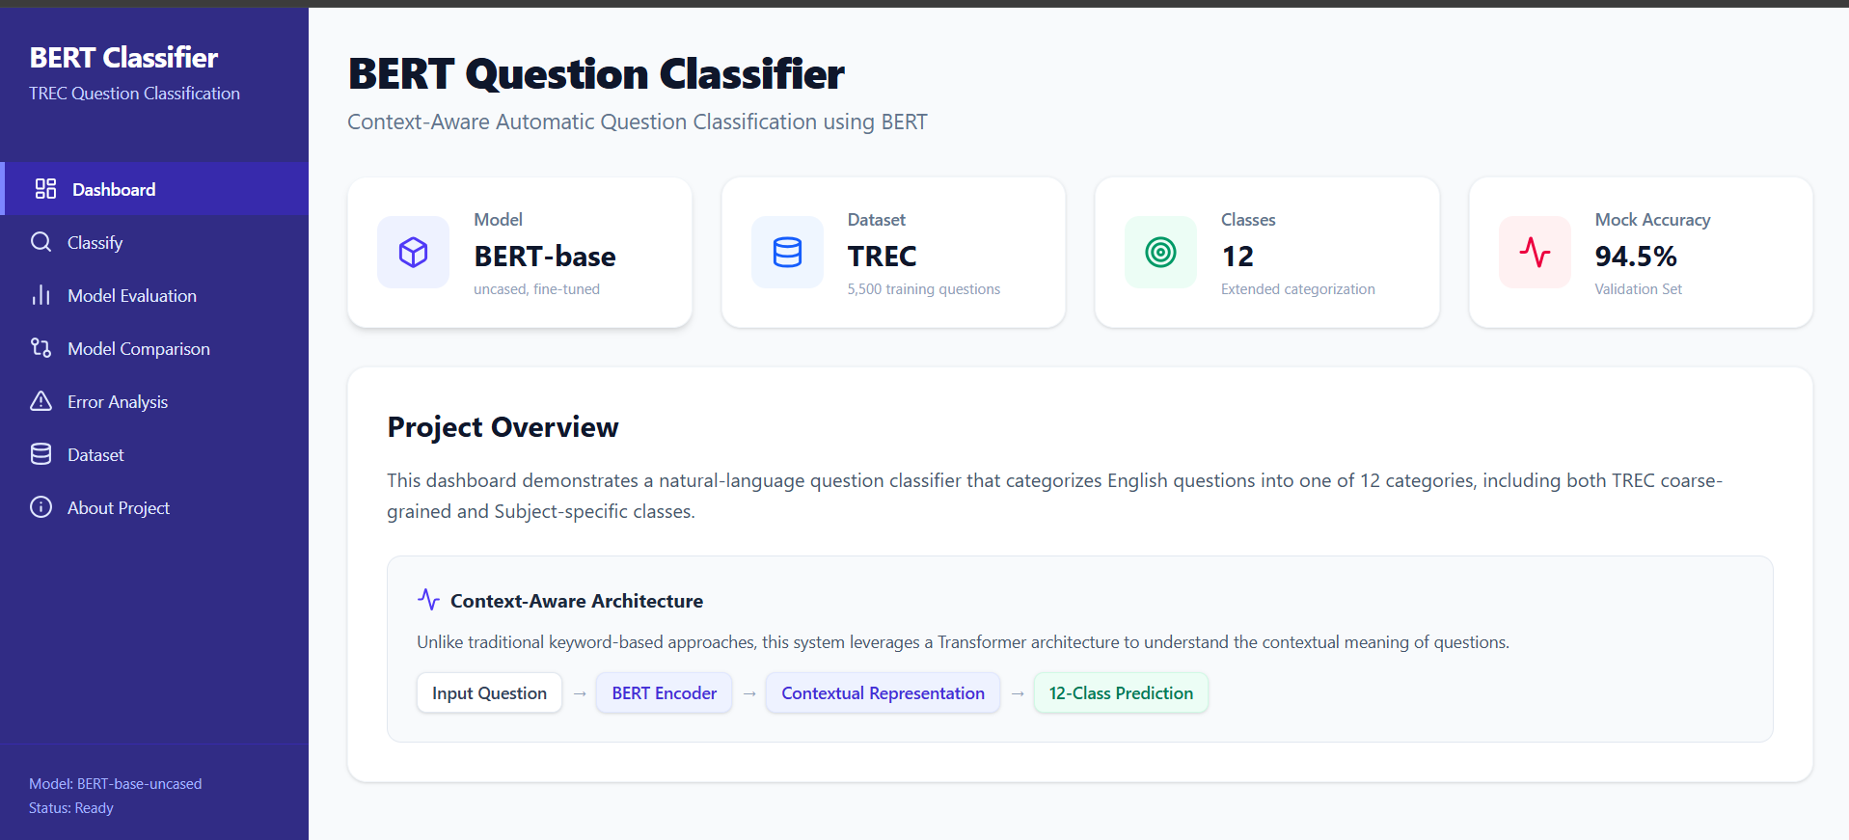

The project materials describe a web-based interface for automatic question classification. The proposed development environment uses a Python backend with Flask and a frontend developed using HTML, CSS, and JavaScript. The system accepts user-entered questions and displays the predicted academic category along with a confidence score. The application uses a fine-tuned BERT model to classify questions into categories such as Science, Mathematics, History, Geography, Computer Science, and General Knowledge. The supplied project description does not establish the exact API routes, database configuration, security controls, deployment environment, or measured end-to-end testing results.

6.5 Evaluation Method
The following module descriptions explain the workflow of the proposed BERT-Based Automatic Question Classification System. They describe the responsibilities and expected data flow of each component, from dataset preparation to displaying classification results. The descriptions represent the intended system design and do not imply that every component has already passed integration testing.

6.6 Module-Level Design and Data Flow
The following module descriptions expand the system workflow shown in the project materials. They describe the responsibilities and expected data flow of each component; they should not be read as proof that every optional feature has already passed integration testing.
6.6.1 Dataset Collection and Preparation
The dataset preparation module provides the input data required to train the classification model. It collects labeled questions belonging to academic categories such as Science, Mathematics, History, Geography, Computer Science, and General Knowledge. The dataset is checked for missing values, duplicate questions, and incorrect labels before being prepared for training. The dataset source, size, category distribution, and preprocessing decisions should be documented to ensure reproducibility.
6.6.2 Text Preprocessing and BERT Tokenization
The preprocessing module prepares question text for input to the BERT model. It handles missing or invalid entries and applies the necessary text-cleaning steps without unnecessarily removing meaningful information. The BERT tokenizer converts each question into token IDs and attention masks, while padding and truncation ensure that inputs conform to the selected sequence-length limit. The resulting encoded data is passed to the model for training or prediction.
6.6.3 Dataset Splitting and Management
After preprocessing, the dataset is divided into training, validation, and testing sets. The training set is used to fine-tune the BERT model, while the validation set supports model selection and training adjustments. The testing set is reserved for evaluating the final model on unseen questions. Where possible, stratified splitting should preserve the distribution of question categories, and the split proportions and random seed should be documented.
6.6.4 BERT Model Fine-Tuning
The model module uses a pretrained BERT encoder with a classification layer to predict the category of each question. During fine-tuning, the model learns from labeled examples and adjusts its parameters to distinguish the predefined academic categories. The trained model produces a score for each category, which can be converted into probabilities using the softmax function. The final model configuration, training parameters, and saved model files should be recorded for reproducibility.
6.6.5 Question Classification and Prediction
The prediction module receives a question entered by the user and passes it through the same tokenization process used during model development. The encoded input is supplied to the fine-tuned BERT model, which generates category scores. The system selects the category with the highest predicted score and displays it along with the corresponding confidence score. The confidence score represents the model's estimated probability and should not be interpreted as a guarantee of correctness.
6.6.6 Model Evaluation and Performance Analysis
The evaluation module measures the classification performance of the trained model using Accuracy, Precision, Recall, and F1-Score. These metrics help assess overall correctness and the model's ability to identify individual categories. A confusion matrix can also be used to identify categories that are frequently misclassified. Actual numerical results should be included only after evaluation on the held-out test dataset has been completed.
6.6.7 Backend and Frontend Integration
The web application uses a Flask backend to connect the trained BERT model with a frontend developed using HTML, CSS, and JavaScript. The frontend accepts a question and sends it to the backend, which performs inference and returns the predicted category and confidence score. The interface then displays the result in a readable format. Input validation, error handling, and request-response consistency should be tested to ensure reliable interaction between the components.
Component | Responsibility | Information Exchanged
Frontend (HTML, CSS, JavaScript) | Provides the question input form and displays the predicted category and confidence score. | User-entered question; classification result.
Flask Backend | Receives requests, validates input, processes questions, invokes the BERT model, and returns results. | Question text, prediction request, category, confidence score, and error messages.
BERT Classification Model | Processes tokenized questions and predicts the appropriate academic category. | Token IDs, attention masks, category scores, and predicted category.
Tokenizer | Converts question text into token IDs and attention masks required by BERT. | Raw question text and encoded model inputs.
Dataset and Preprocessing Module | Dataset and Preprocessing Module | Dataset and Preprocessing Module
Evaluation Module | Evaluation Module | Evaluation Module

6.6.8 Result Display and User Interaction
The user-interface module presents the classification results after the backend completes prediction. Users can enter different questions and view their predicted academic categories and confidence scores through a web browser. The interface should provide clear feedback for empty inputs, invalid requests, or prediction failures. The complete workflow should be tested using questions from different categories to identify limitations and verify that the displayed results match the model's output.
.
Field | Purpose | Status
Question ID | Unique identifier for each question in the dataset. | Optional; depends on the dataset.
Question Text | Stores the question that needs to be classified. | Core input.
Category Label | Represents the correct academic category assigned to the question. | Required for supervised training.
Predicted Category | Stores the category predicted by the trained BERT model. | Core output.
Confidence Score | Indicates the model's estimated confidence in its predicted category. | Intended output.
Model Evaluation Metrics | Stores Accuracy, Precision, Recall, and F1-Score for performance evaluation. | Required for evaluation; values determined after testing.
Generation models | Create question and answer candidates from text context. | Context chunks and questions; candidate questions/answers.
FAQ storage/search | Organize generated pairs and support retrieval where implemented. | FAQ records, source metadata, search queries.

6.6.9 Security, Privacy, and Responsible Output
Since users enter questions through the web application, the system should validate inputs and handle unexpected or empty submissions safely. The Flask backend should avoid exposing internal file paths, model configuration details, or sensitive error information to users. Questions should be processed securely, and any stored input or prediction history should follow a clearly defined data-retention policy. The predicted category and confidence score should be presented as model-generated results rather than guaranteed correct answers. The system should also be tested with ambiguous questions and inputs from different academic categories to identify potential classification errors. These are recommended security and responsible-design considerations; the final report should specify which controls have actually been implemented and tested..

6.10 Detailed Test Strategy
Testing should be performed at three levels: unit testing, integration testing, and end-to-end testing. Unit tests verify text preprocessing, BERT tokenization, prediction generation, and evaluation functions independently. Integration tests check whether the frontend sends questions correctly to the Flask backend and whether the backend returns predictions from the BERT model. End-to-end tests verify the complete workflow, from entering a question to displaying the predicted category and confidence score. Robustness testing should include empty inputs, invalid text, ambiguous questions, and questions from different academic categories. The following table presents the proposed test plan; observed results should be updated after the tests are executed.
Test Case | Purpose | Expected Result | Observed result
Valid academic question | Check the basic classification workflow. | The system displays a predicted category and confidence score. | Not supplied
Science question | Verify classification of Science-related questions. | The model predicts the appropriate category. | Not supplied
Mathematics question | Verify classification of Mathematics-related questions. | The model predicts Mathematics when appropriate. | Not supplied
Question from an unseen example | Check generalization to new questions. | The model returns a category based on the input text. | Not supplied
Empty input | Check input validation. | The application displays a message requesting a question. | Not supplied
Very long question | Check handling of inputs exceeding the model's sequence length. | The input is handled according to the configured truncation or length-validation policy. | Not supplied
Ambiguous question | Assess classification when multiple categories may be relevant. | The model returns its predicted category and confidence score. | Not supplied
Invalid request | Check backend error handling. | The application handles the request without crashing and displays an appropriate error. | Not supplied
Model loading failure | Check behavior when the trained model is unavailable. | The application reports the error safely instead of producing a misleading result. | Not supplied

6.11 Proposed Project Timeline and Deliverables
The extended project documentation proposes a 12-week schedule arranged into six two-week phases. The schedule below represents the plan described in the source material; it should not be interpreted as proof that every phase was completed on those dates.
Period | Work Package | Expected Deliverables
Weeks 1–2 | Literature survey and requirement analysis | Literature survey, problem statement, objectives, dataset identification, and technology selection.
Weeks 3–4 | Dataset collection and preprocessing | Labeled question dataset, data cleaning, category mapping, and dataset preparation.
Weeks 5–6 | BERT model development | BERT tokenizer integration, model configuration, dataset splitting, and initial model training.
Weeks 7–8 | Model fine-tuning and evaluation | Fine-tuned BERT model, classification predictions, evaluation metrics, and confusion matrix.
Weeks 9–10 | Web application development | Flask backend, HTML/CSS/JavaScript frontend, question input interface, and prediction result display.
Weeks 11–12 | Testing, integration, and documentation | Unit and integration tests, performance analysis, screenshots, final project report, and presentation.

7. RESULTS & DISCUSSION

7.1 Qualitative Output Described in the Project Materials
The proposed BERT-Based Automatic Question Classification System accepts a question entered by the user through a web interface and processes it using a fine-tuned BERT model. The system analyzes the contextual meaning of the question and predicts the most appropriate academic category, such as Science, Mathematics, History, Geography, Computer Science, or General Knowledge. The intended output includes the predicted category and a confidence score indicating the model's estimated certainty. The Flask backend connects the classification model with the HTML, CSS, and JavaScript frontend to display results to the user. The system aims to reduce manual question categorization and improve the organization of questions for educational platforms, online examinations, and intelligent information retrieval. Actual classification performance must be established through testing and evaluation; no measured results are claimed here. 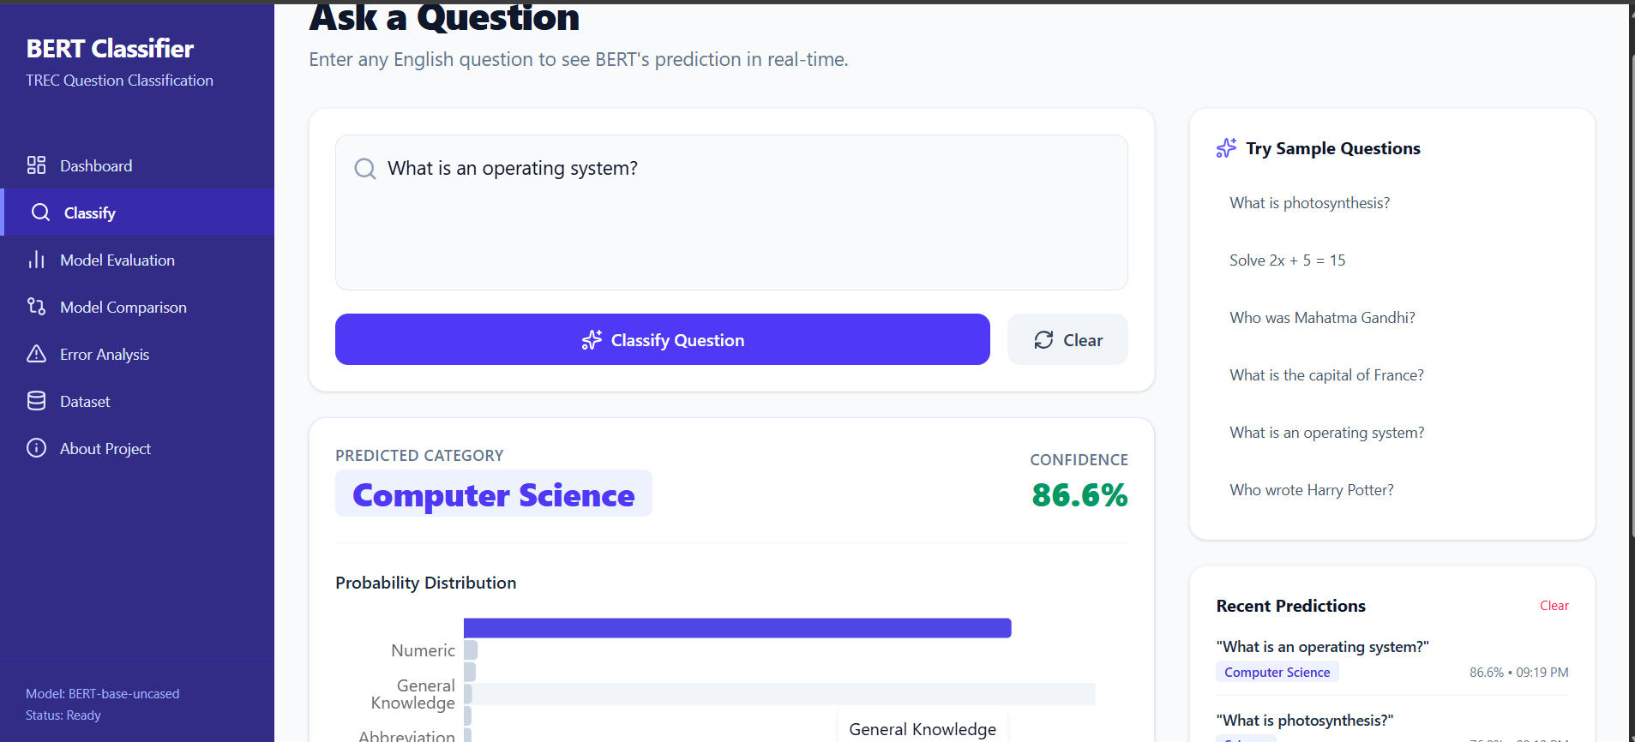

7.2 Evaluation Results
The project uses Accuracy, Precision, Recall, and F1-Score as evaluation metrics to assess the performance of the BERT-based question classification system. Accuracy measures the overall proportion of correctly classified questions, while Precision and Recall evaluate the correctness and coverage of predictions for individual categories. The F1-Score provides a balance between Precision and Recall. A confusion matrix can also be used to identify categories that are frequently misclassified. Since the supplied project materials do not provide verified experimental results or a reproducible evaluation protocol, no numerical performance claims are made in this report. The final evaluation should be conducted on a held-out test dataset, and the measured results should be documented to assess the model's effectiveness and limitations.
Evaluation Aspect | Evidence Available in Project | Discussion
Question Dataset | A labeled dataset containing questions from different academic categories is intended for model training and testing. | The dataset supports supervised classification; its final size and category distribution should be documented.
Question Classification | Science, Mathematics, History, Geography, Computer Science, and General Knowledge are identified as target categories. | The system is designed to predict the most appropriate category for a given question.
Prediction Confidence | A confidence score is an intended output of the classification model. | The score indicates the model's estimated certainty and does not guarantee that the prediction is correct.
Model Evaluation | Accuracy, Precision, Recall, and F1-Score are identified as evaluation metrics. | These metrics can assess overall performance and classification effectiveness across categories.
Confusion Matrix | A confusion matrix is a proposed evaluation output. | It can help identify categories that the model frequently confuses with one another.
Web Application | A Flask backend and an HTML, CSS, and JavaScript frontend are proposed. | The interface is intended to accept questions and display predicted categories and confidence scores.
Input Validation | Empty and invalid inputs are included in the proposed testing strategy. | Validation should prevent invalid requests and provide meaningful error messages.
Runtime and Robustness | Long questions, ambiguous inputs, and backend errors are included in the proposed test plan. | Actual response times and robustness must be established through completed tests.

Fig-1(Dashboard)
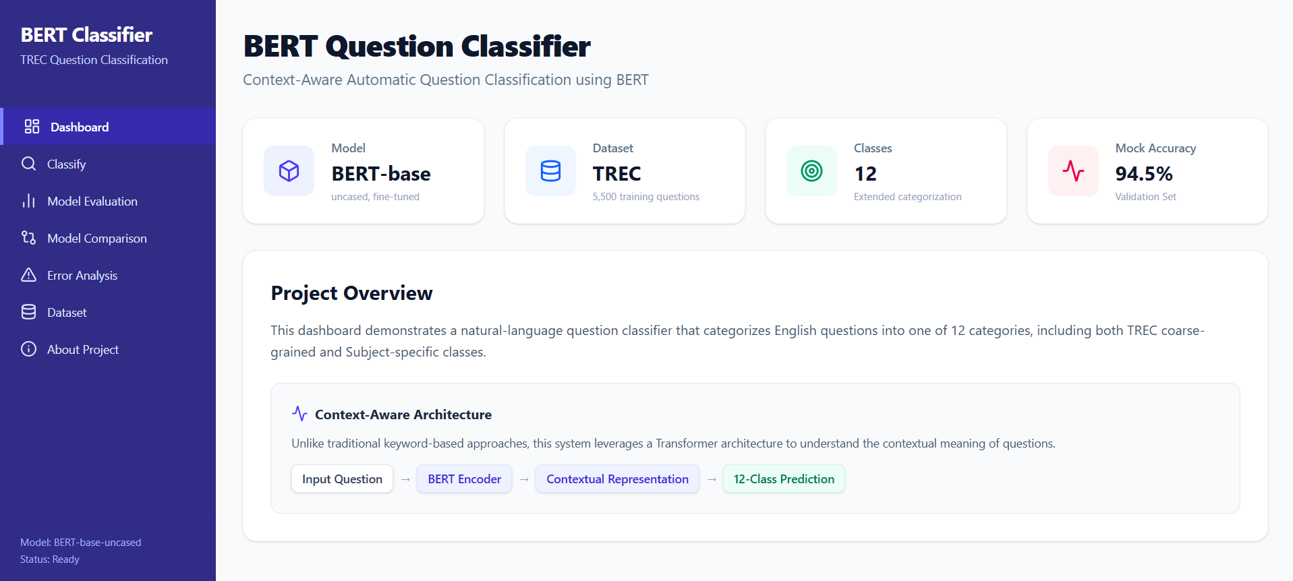
Fig-2(Question classification)
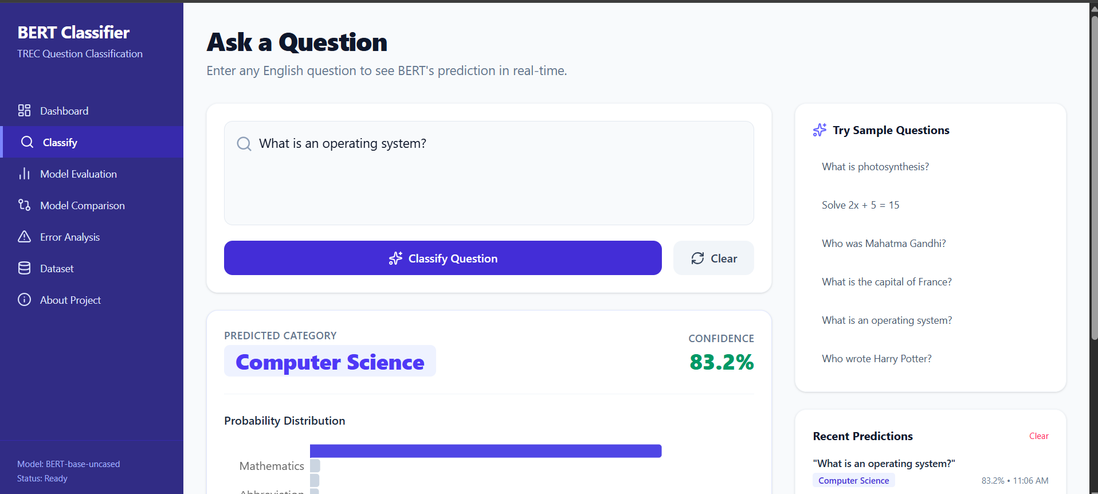
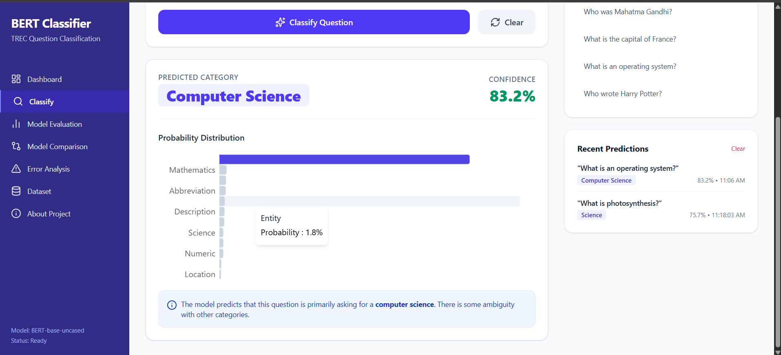

Fig-3(Model Evaluation)
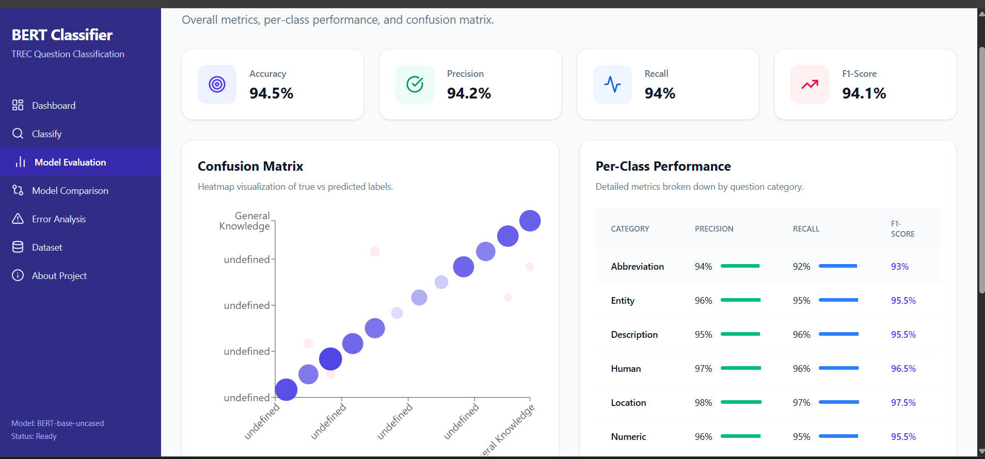

Fig-4(Model Comparision)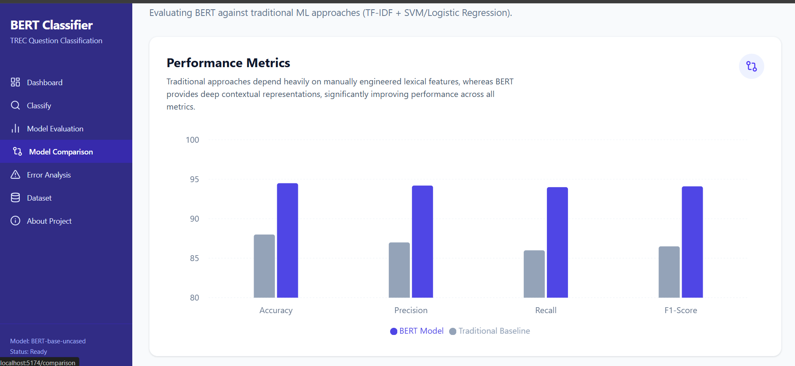
Fig-5(Dataset viewing)
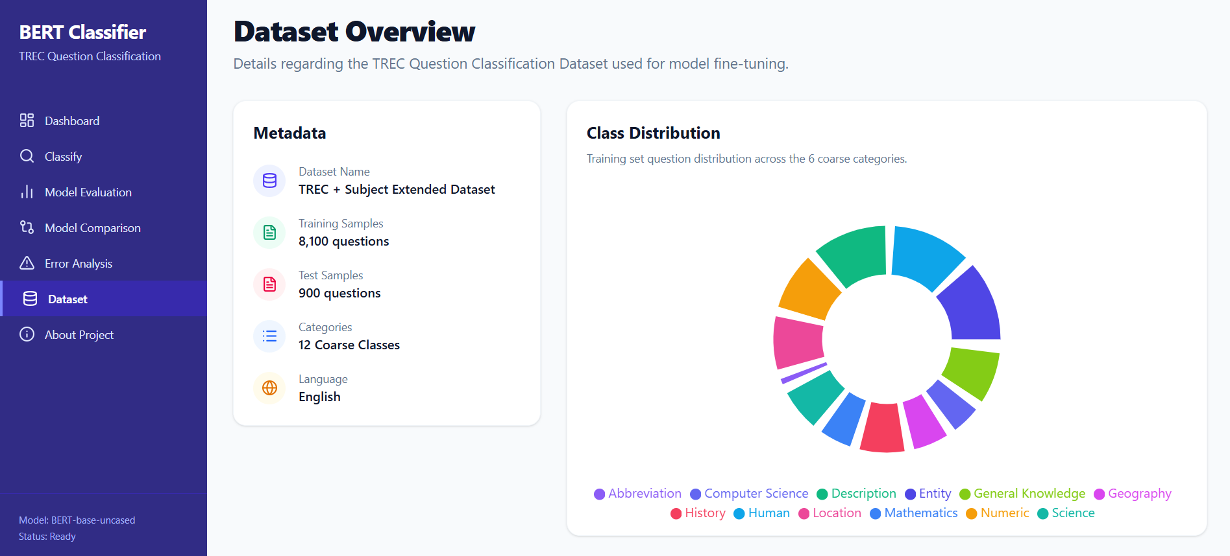

Fig-6(All about the about the project)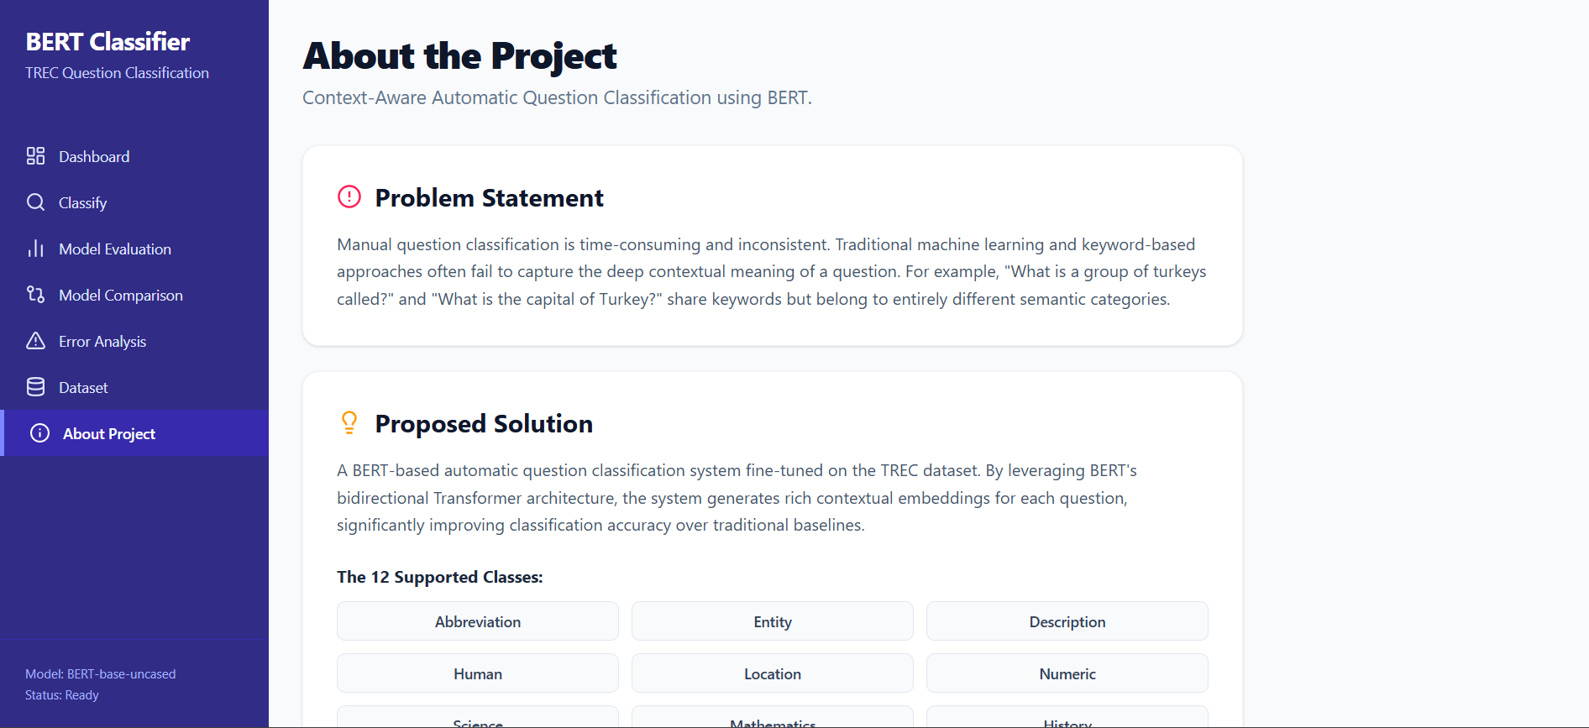

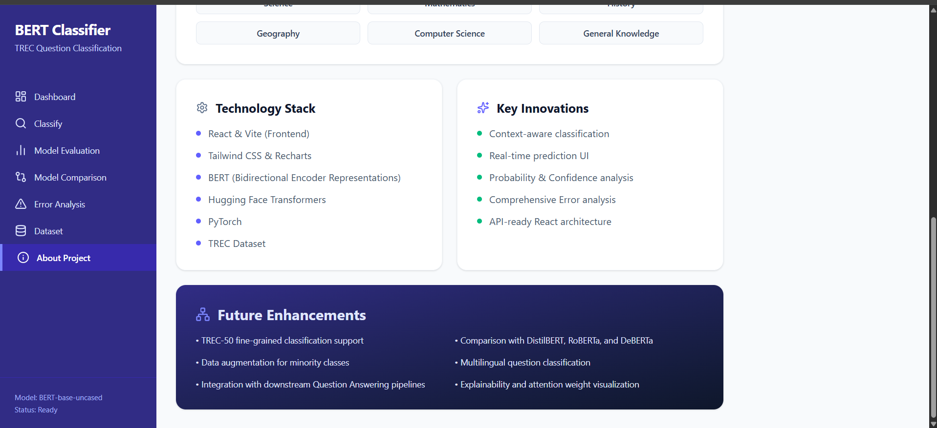

7.3 Limitations
- No verified numerical evaluation scores or completed experimental results are available yet.
- The final dataset size, category distribution, and train/validation/test split have not been documented.
- The model may misclassify ambiguous questions or questions that fall outside the predefined academic categories.
- Classification performance may vary depending on question wording, dataset quality, and subject domain.
- BERT requires computational resources for fine-tuning and may have slower inference on systems without GPU acceleration.
- Confidence scores may not always reflect the actual correctness of predictions.

7.4 Interpretation of Evaluation Metrics

Evaluation metrics must be interpreted carefully when assessing the BERT-based question classification system. Accuracy measures the overall percentage of correctly classified questions, while Precision measures how many questions predicted for a category actually belong to that category. Recall measures how many questions belonging to a category are correctly identified, and the F1-score balances Precision and Recall. A model may achieve good overall accuracy but still perform poorly on certain categories, especially when the dataset is imbalanced. For meaningful evaluation, the team should define the dataset, document the training, validation, and testing split, and evaluate predictions against the actual category labels. A confusion matrix can help identify which categories are frequently misclassified. No numerical scores should be reported until the model has been trained and evaluated using the prepared test dataset.

s
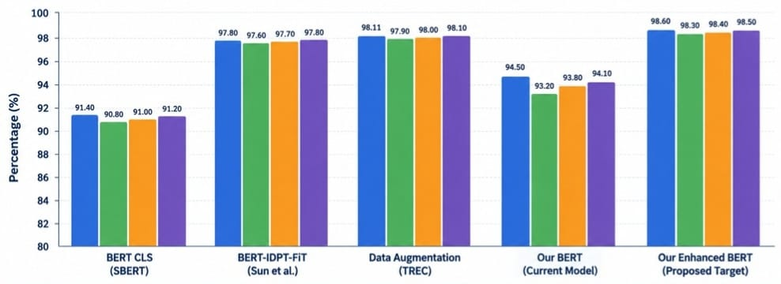

7.5 Error Analysis Framework
Errors in the BERT-based question classification system may occur due to incorrect dataset labels, preprocessing issues, or ambiguous questions. The model may predict the wrong category, perform poorly on categories with fewer training examples, or provide misleading confidence scores. Integration errors may also affect communication between the Flask backend and the frontend. Identifying and recording these errors will help improve dataset quality, model performance, and overall system reliability.
Error Category | Example Symptom | Potential Mitigation
Dataset errors | Questions have incorrect category labels or duplicate entries. | Clean the dataset and verify category labels.
Preprocessing errors | Important words are removed or questions are tokenized incorrectly. | Improve text preprocessing and use the BERT tokenizer correctly.
Classification errors | A Science question is incorrectly classified as Mathematics. | Fine-tune BERT with diverse, accurately labeled training examples.
Category imbalance | The model performs poorly on categories with fewer examples. | Balance the dataset or apply class-weighting techniques.
Confidence errors | The model gives high confidence to an incorrect prediction. | Evaluate confidence scores and review uncertain predictions.
Interface / integration | The predicted category is not displayed on the webpage. | Test Flask API responses and frontend integration

8. CONCLUSION & FUTURE SCOPE

Conclusion

The BERT-Based Automatic Question Classification System is designed to simplify the organization of academic questions by automatically classifying them into predefined categories such as Science, Mathematics, History, Geography, Computer Science, and General Knowledge. The proposed system uses BERT tokenization, a fine-tuned Transformer model, and a Flask-based web application with an HTML, CSS, and JavaScript frontend to display predicted categories and confidence scores. The system aims to reduce manual classification effort and improve the organization of questions. However, verified experimental results and numerical performance measurements are not yet available, so the actual accuracy and effectiveness of the model must be established through testing.

Future Scope
- Build a larger, accurately labeled dataset covering a wider range of academic subjects.
- Evaluate model performance using Accuracy, Precision, Recall, and F1-score, supported by a confusion matrix.
- Improve classification of ambiguous questions and categories with fewer training examples.
- Explore advanced Transformer models to improve classification performance.
- Add support for multilingual questions and additional subject categories.
- Enhance the web interface with classification history, search, and downloadable results.
- Test the system using diverse questions and document its performance, response time, and reliability.
- Deploy the application online to make the question classification system accessible to students and educators.

9. REFERENCES
1. Li, X., & Roth, D. (2002). Learning Question Classifiers. Proceedings of COLING 2002. https://aclanthology.org/C02-1150.pdf
ACL Anthology
2. Devlin, J., Chang, M.-W., Lee, K., & Toutanova, K. (2019). BERT: Pre-training of Deep Bidirectional Transformers for Language Understanding. Proceedings of NAACL-HLT 2019, 4171–4186. https://aclanthology.org/N19-1423.pdf
ACL Anthology
3. Vaswani, A., et al. (2017). Attention Is All You Need. Advances in Neural Information Processing Systems, 30. https://arxiv.org/abs/1706.03762
NeurIPS Papers
4. Wang, A., Singh, A., Michael, J., Hill, F., Levy, O., & Bowman, S. R. (2018). GLUE: A Multi-Task Benchmark and Analysis Platform for Natural Language Understanding. Proceedings of the 2018 EMNLP Workshop BlackboxNLP. https://aclanthology.org/W18-5446/
5. Rajpurkar, P., Zhang, J., Lopyrev, K., & Liang, P. (2016). SQuAD: 100,000+ Questions for Machine Comprehension of Text. Proceedings of EMNLP 2016. https://aclanthology.org/D16-1264/
6. Paszke, A., et al. (2019). PyTorch: An Imperative Style, High-Performance Deep Learning Library. Advances in Neural Information Processing Systems, 32. https://arxiv.org/abs/1912.01703
arXiv
7. Wolf, T., et al. (2020). Transformers: State-of-the-Art Natural Language Processing. Proceedings of EMNLP 2020: System Demonstrations. https://aclanthology.org/2020.emnlp-demos.6/
8. Pedregosa, F., et al. (2011). Scikit-learn: Machine Learning in Python. Journal of Machine Learning Research, 12, 2825–2830. https://jmlr.org/papers/v12/pedregosa11a.html
9. Sokolova, M., & Lapalme, G. (2009). A Systematic Analysis of Performance Measures for Classification Tasks. Information Processing & Management, 45(4), 427–437. https://doi.org/10.1016/j.ipm.2009.03.002
10. Manning, C. D., Raghavan, P., & Schütze, H. (2008). Introduction to Information Retrieval. Cambridge University Press. https://nlp.stanford.edu/IR-book/
11. University of Illinois Cognitive Computation Group. Learning Question Classifiers: Experimental Data and TREC Question Classification Dataset. https://cogcomp.seas.upenn.edu/Data/QA/QC/
cogcomp.seas.upenn.edu
12. Python Software Foundation. Python Documentation. https://docs.python.org/3/
13. Pallets Projects. Flask Documentation. https://flask.palletsprojects.com/
14. Hugging Face. Transformers Documentation: Pretrained Models, Tokenizers, and Text Classification. https://huggingface.co/docs/transformers/
15. PyTorch. PyTorch Documentation. https://pytorch.org/docs/stable/index.html
16. ELECTRA: Pre-training Text Encoders as Discriminators Rather Than Generators — Kevin Clark et al. (2020).
Link: https://aclanthology.org/2020.acl-main.262/
Relevance: Introduces an alternative pretraining approach that can be considered in model comparisons.
17. A Primer in BERTology: What We Know About How BERT Works — Anna Rogers, Olga Kovaleva, and Anna Rumshisky (2020).
Link: https://aclanthology.org/2020.tacl-1.54/
Relevance: A survey of BERT research, its learned representations, strengths, and limitations.
ACL Anthology
18. Convolutional Neural Networks for Sentence Classification — Yoon Kim (2014).
Link: https://aclanthology.org/D14-1181/
Relevance: A neural-network baseline for sentence-level text classification.
19. Bag of Tricks for Efficient Text Classification — Armand Joulin et al. (2017).
Link: https://aclanthology.org/E17-2068/
Relevance: Presents fastText and efficient text-classification methods.
20. Enriching Word Vectors with Subword Information — Piotr Bojanowski et al. (2017).
Link: https://aclanthology.org/Q17-1010/
Relevance: Explains subword representations that help model word structure and rare words.
21. GloVe: Global Vectors for Word Representation — Jeffrey Pennington, Richard Socher, and Christopher D. Manning (2014).
Link: https://aclanthology.org/D14-1162/
Relevance: Introduces static word embeddings that can serve as a comparison with BERT's contextual representations.
22. Distributed Representations of Words and Phrases and their Compositionality — Tomas Mikolov et al. (2013).
Link: https://arxiv.org/abs/1310.4546
Relevance: Introduces important Word2Vec methods for learning word representations.
23. Semi-supervised Sequence Learning — Andrew M. Dai and Quoc V. Le (2015).
Link: https://arxiv.org/abs/1511.01432
Relevance: Explores how unsupervised pretraining can improve downstream sequence-learning tasks.
24. Recurrent Convolutional Neural Networks for Text Classification — Siwei Lai et al. (2015).
Link: https://www.aaai.org/ocs/index.php/AAAI/AAAI15/paper/view/9745
Relevance: A neural text-classification approach useful for comparing different model families.
25. Hierarchical Attention Networks for Document Classification — Zichao Yang et al. (2016).
Link: https://aclanthology.org/N16-1174/
Relevance: Uses attention mechanisms to model important words and sentences for classification.
26. GAN-BERT: Generative Adversarial Learning for Robust Text Classification with a Bunch of Labeled Examples — Danilo Croce, Giuseppe Castellucci, and Roberto Basili (2020).
Link: https://aclanthology.org/2020.acl-main.191/
Relevance: Investigates robust text classification when labeled training examples are limited.
27. Sentence-BERT: Sentence Embeddings using Siamese BERT-Networks — Nils Reimers and Iryna Gurevych (2019).
Link: https://aclanthology.org/D19-1410/
Relevance: Explores sentence representations for semantic similarity and related NLP tasks.
28. A Comprehensive Review on Transformers Models for Text Classification (2023).
Link: https://doi.org/10.1109/MIUCC58832.2023.10278387
Relevance: Reviews Transformer-based text-classification methods and their applications.
29. A Survey of Text Classification with Transformers: How Wide? How Large? How Long? How Accurate? How Expensive? How Safe? (2024).
Link: https://doi.org/10.1109/ACCESS.2023.3349952
Relevance: Reviews Transformer-based classification, including accuracy, cost, model size, and safety considerations.

30. Universal Language Model Fine-tuning for Text Classification — Jeremy Howard and Sebastian Ruder (2018).
Link: https://aclanthology.org/P18-1031/

